Lesson 5
13th January 2022

Reading

COVID-19 vaccinations
All eligible people aged 18 or over can now make an appointment to get their booster jab (vaccinazione di richiamo) at one of thousands of vaccination centres across the country.
NHS colleagues are prioritising booked jabs so the best way to get your booster is to make an appointment.
If you are aged 18 or over, or are already eligible, please book your booster vaccination now.
You can book your booster to take place three months after your last dose using the National Booking Service or by calling 119. You can pre-book a booster if it’s been two months since your second dose – the appointment dates you’ll be offered will be from three months after your second dose.

booster https://www.wordreference.com/enit/booster
JAB https://www.wordreference.com/enit/jab
NHS National Health Service/ sistema sanitario nazionale
Eligible https://www.wordreference.com/enit/eligible
Book https://www.wordreference.com/enit/book
take place https://www.wordreference.com/enit/take%20place

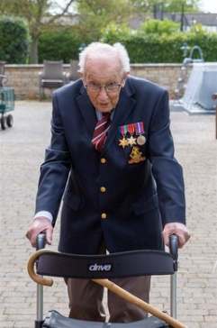
Captain Sir Thomas Moore (30 April 1920 – 2 February 2021), more popularly known as Captain Tom, was a British Army officer and fundraiser who made international headlines in 2020 when he raised money for charity in the run-up to his 100th birthday during the COVID-19 pandemic
Captain Sir Thomas Moore https://captaintom.org/
raised money https://www.wordreference.com/enit/raise%20money
run-up https://www.wordreference.com/enit/run-up

London's 2021 fireworks 🎆 Happy New Year Live! 🔴 BBC (10.01)

https://www.youtube.com/watch?v=MpJIg_3DnLk

Hang on https://www.wordreference.com/enit/hang%20on

I think you’re on mute. Penso che tu abbia il microfono spento
Consultant https://www.wordreference.com/enit/consultants
Matter https://www.wordreference.com/enit/matter
Turn your life around dare una svolta alla tua vita https://www.wordreference.com/enit/turn%20around

Happy New Year Live! 🎆 London Fireworks 2022 🔴 BBC

https://www.youtube.com/watch?v=VurcwV-3zNc

Big Ben tolls as the UK marks the start of 2022
The UK's "spectacular" began with a countdown to midnight on the Shard, before a monologue took place following a scattering of fireworks on the Millennium Bridge.

The speech walked through the UK's achievements this year, including the successes of the Tokyo Olympics and Emma Raducanu's win at the US Open.

Cameras then cut to displays at the Old Royal Naval College in Greenwich, where an impressive drone show took place amid a dazzling display of colourful fireworks.

Later, the West End musical choir performed a medley of ABBA songs inside the Globe Theatre.
And then we returned to Greenwich for a short ode to Sir Elton John and a stunning pyrotechnic display set to music.

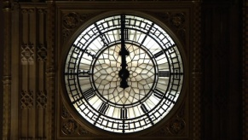

Relish https://www.wordreference.com/enit/turn%20around

Rally round https://www.wordreference.com/enit/rally%20round

Dazzling https://www.wordreference.com/enit/dazzling

choir https://www.wordreference.com/enit/choir

medley https://www.wordreference.com/enit/medley

HOMEWORK
Read the two readings above
- First silent reading: try to understand the global meaning without traslating.
- Second silent reading: Clarify the meanig of the word you don’t understand using: https://www.wordreference.com . The wors in red in the boxes under the readings might be quite useful for you.
- Third reading. Now you should understand everyting.
Watch the two clips
- The first one with subtitles
- The second one has no subtitles so Watch the clip many times.
If you don’t understand some part of the monologue You can modify the speech speed, pitch and volume. Have a look at this explanation: https://www.youtube.com/watch?v=_gSbxcvDURk

